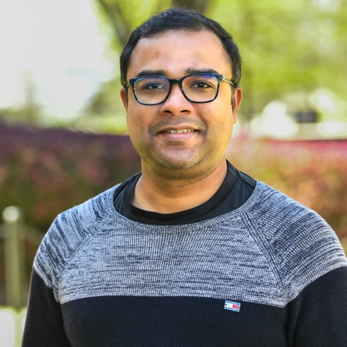

**Bio:** Dr. Shubhra Kanti Karmaker (``Santu'') (Co-PI) is an Assistant Professor in the Department of Computer Science and Software Engineering at Auburn University, Alabama. With a broad interest in the academic field of Artificial Intelligence and Data Science, his primary research focus lies at the intersection of Natural Language Processing (NLP) and Information Retrieval (IR). More specifically, his research is primarily driven by the following broad research question: “*How can we make AI/Data Science more accessible and useful to the end users in order to democratize AI to a broader audience*?”

Dr. Karmaker completed his Ph.D. in Computer Science from the University of Illinois Urbana Champaign (**UIUC**) and was then a Postdoctoral Research Associate in the Laboratory for Information and Decision Systems (**LIDS**) at the Massachusetts Institute of Technology (**MIT**). During his Ph.D., he also worked as a summer research intern at Microsoft Research, Yahoo Research, and @WalmartLabs. As a researcher, Dr. Karmaker has published **30 research papers** at premier venues, including ACL, EMNLP, SIGIR, WWW, TMLR, COLING, CoNLL, AACL, CIKM, IUI, ACM TIST, and ACM Computing Surveys. To support his research, Dr. Karmaker has brought over **$1.4 million** in total grants as the **Lead PI** from multiple funding agencies, including the National Science Foundation (**NSF**), Air Force Office of Scientific Research (**AFOSR**), Army Research Office (**ARO**) and US Dept. of Agriculture (**USDA**). For external service, he currently serves as an action editor for the ACL Rolling Review Initiative (**ARR**) and also as the **communication chair** of the ARR initiative. Dr. Karmaker also served as the tutorial chair for CIKM 2022. He has served regularly as a program committee member for ACL and SIGIR-sponsored conferences for the last five years. For more details about the speaker, please visit <https://karmake2.github.io/>.